**Thermoelectric Carbon Monoxide Sensor Using Co-Ce Catalyst**（小三，加粗，居中，段前1行，段后0行）

学号 姓名 （宋体，小四，居中，段前段后各0.5行）导师

（正文，五号，行距12磅，段前段后0行，参考文献标注用上标）（英文用Times New Roman）

**Abstract**： A thermoelectric (TE) carbon monoxide sensor was obtained composed of Co-Ce catalyst layer and TE layer. The Co-Ce catalysts were prepared by co-precipitation and tabletting method. Several factors including the atomic ratio of Co/Ce, pH value, calcination temperature, and operating temperature were investigated. EDS analysis was utilized to determine the final composition between Co and Ce. Methods of BET, XRD, SEM were used to characterize the catalysts. When Co10.0Ce catalyst showed a high temperature difference output (44oC) at an operating temperature of 92°C, the TE sensor possessed well sensing property to 3 vol.% CO, with a high output voltage signal (42 mV). The response and recovery time of the TE sensor was 72 s and 68 s, respectively. Furthermore, high selectivity of the sensor was also obtained in the operating temperature from 90°C to 125°C.

***Keywords****:* Catalyst, Carbon monoxide sensor, Thermoelectric film（关键字、摘要的具体格式请仿照本文）

**1. Introduction（五号，加粗，段前段后各0.5行）**

Carbon monoxide (CO) is one of the common poisonous gases, even concentration as 1 vol.% CO can be fatal. The colorless, odorless as well as non-irritating natures of CO make it difficult to be detected, and the hazard of CO is exacerbated by its wide sources. As a result, CO sensors are indispensable in many fields, such as measuring the CO concentration of vehicle emissions, industrial waste, and the indoor atmosphere. Currently, the CO sensors based on electrochemical or semi-conductor methods have been widely used, but they still have some shortage on selectivity, long-term stability, complex configurations and high cost.

In this paper, the Co-Ce oxide was used to trigger the sensor possessing high sensitivity and selectivity to CO at low operating temperature. Following these considerations, the Co-Ce oxides over CO oxidation were studied. All the oxides were prepared by co-precipitation and tabletting method. Surface area, pore volume, crystal structure, oxidation-reduction behavior of the Co and Co-Ce oxides were characterized subsequently by BET, XRD and SEM methods. Finally, using the optimal Co-Ce oxide, CO sensing property of the TE gas sensor was discussed.

**2. Experimental**

2.1 Catalyst Preparation（五号，段前段后各0.5行）

The Co-Ce oxides were prepared by the co-precipitation method in an aqueous solution. A mixed solution of Co(NO3)2·6H2O and Ce(NO3)3·6H2O was gradually added into NH4HCO3 solution drop wisely with continuous stirring. The precipitation process was carried out at 45-50°C. The slurry was aged for 9 hr, then filtered, and washed with de-ionized water several times until the pH of the filtrate kept as 7. The precipitate was dried in an oven at 100°C for 2 hr, after that, the as-dried powder was formed by tabletting method with the pressure varied from 1 MPa to 6 MPa. For all experiments, pellets with the same weight of 200 mg were utilized. Finally, all samples were calcined in air, utilizing various temperatures ranged from 250°C to 500°C.

The Co-Ce oxides were described as CoxCe1 (x as the atomic ratio of Co to Ce) in the following content. The pure Co oxides without Ce additive were also prepared by the similar procedures for comparison.

2.2 Catalyst Characterization

Energy dispersion spectroscopy (EDS, Falcon, USA) method was used to test the final composition of Co/Ce of the formed Co-Ce oxides. BET method was used to measure the surface areas of the samples by nitrogen adsorption at -196°C. The pretreatment was degasificated at 190°C for 6 hr, using a Micrometric ASAP2010 (USA) instrument in an automatic volumetric system. X-ray diffraction (XRD) spectra were obtained using a D/max2550 VB/PC X-ray diffractometer (Rigaku, Japan). Scanning electron microscope (SEM, JSM-6360LV) method was characterized by X-ray diffractometry (JEOL, Japan).

2.3 Catalytic activity and TE sensing property

Bismuth telluride was chosen as TE material for the remarkable Seebeck coefficient[1]. TE CO sensor with simple structure was fabricated by employing TE thin film (Bi-Te PN couples) and Co-Ce oxide. The structure of the sensor device is shown in Fig.1. TE layer was deposited onto a quartz glass substrate by magnetron sputtering, Co-Ce oxide centered in the TE film. The concrete size of the device was listed as following: 20 mm (length) × 20 mm (width) × 1 mm (thickness) for substrate, 8 mm × 1 mm × 350 nm for TE layer, 9 mm (diameter) × 2 mm (thickness) for the Co-Ce oxide.

The response of the TE sensor was conducted by flowing alternately 3 vol.% CO/air and N2 into the reaction chamber at a flow rate of 100 ml/min. The measurement was conducted at a constant temperature, which was provided by a silica glass tube heated by a thermal stabilized electric furnace. The catalytic activity was evaluated by the temperature difference (*ΔT*) which built between one side of the TE covered by catalyst and the other side without catalyst. The TE films, working as a feedback part, convert *ΔT* into a voltage as an output signal. All

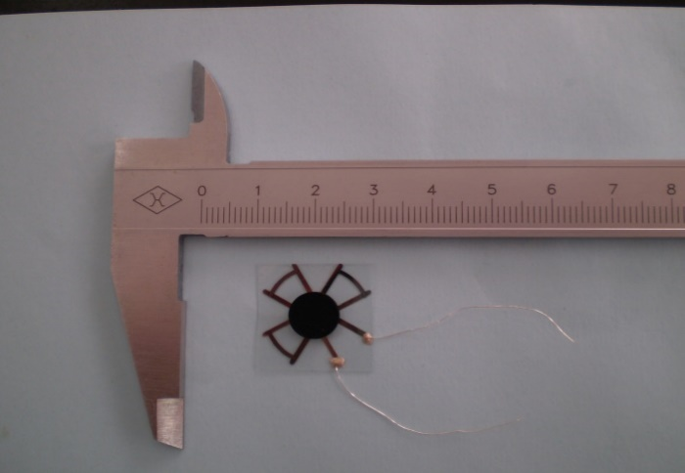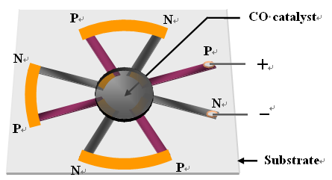

Fig.1 Sketch (left) and picture (right) of the core structure of TE CO sensor.

（五号，居中，图表要放在每页的最上或最下）

data were monitored by a K-type thermocouple, automatically collected and analyzed by Agilent 34970A data acquisition/switch unit and Labview (NI Crop.USA).

**4. Conclusion**

The catalytic activities of Co-Ce oxides were discussed over TE CO sensor. Several parameters of the preparation Co-Ce oxides were investigated, and optimal values were found out as pH value in the co-precipitation process of 7.1, tabletting pressure as 1 MPa, calcination temperature as 400°C. Optimal catalytic activity of the Co10.0Ce was obtained at the operating temperature of 92°C. The performance of the TE CO gas sensor with the optimal Co10.0Ce was studied. The TE sensor exhibited an output voltage signal of 42 mV, the response and recovery time of the sensor were about 72 s and 68 s, respectively. Furthermore, prominent selectivity to CO and no response to H2 and CH4 in this TE CO sensor were achieved.

**References**

[1] H. Huang, W. Luan, J. Zhang, et. al, Thermoelectric Hydrogen Sensor Operating at Room Temperature Prepared by Bismuth Telluride P-N Couples and Pt/γ-Al2O3. Sensors and Actuators B, 2008, 128: 581-585.

[2] L. Xue, C. B. Zhang, H. He, Y. Teraoka, Catalytic Decomposition of N2O over CeO2 Promoted Co3O4 Spinel Catalyst. Applied Catalyst, 2007, 75: 157-164.

（**五号，作者超过三个以上用et al，期刊名称用全称），注意作者姓名的编写方式和各部分的标点符号。不要交叉引用，具体格式参照华东理工大学学报，见文后。此外，最好不要使用Endnote等软件插入参考文献。）**

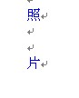**作者简介：（段前1行段后0.5行，加粗）**

XX：1983年生于湖北省天门市，2005年江苏化工学院化工过程机械专业获得学士学位，2005年始在华东理工大学化工过程机械专业攻读硕士学位，2008年毕业。目前在上海轻工业工程设计研究院工作。

Email：[XX@yahoo.com.cn](mailto:XX@yahoo.com.cn)

（作者简介：宋体五号，内容包括出生年月，籍贯，大学以来的简历，Email地址）

照片尺寸3cm（高）X 2.5cm（宽），并且注意照片位置，与左侧中文底边平齐。

注：英文全部用Times New Roman；

页眉用小五，奇偶页内容不同；

页面设置请参考本文；

总长度不超过4页。

华东理工大学学报参考文献格式

1 文稿组成必须包括：文题、作者姓名、作者单位（地址和邮编）、中英文摘要与关键词（3~8个，尽量用汉语主题词表提供的规范词）、中图分类号、英文文题、第一作者简介（姓名、出生年、性别、籍贯、职称、学历、研究方向）、正文、参考文献。基金论文请在文稿首页地脚处注明属何种资助项目。

2  摘要应具有独立性和自含性，即不阅读全文，就能获得必要的信息。摘要应说明研究目的、方法、结果和结论，而重点是结果和结论。中文摘要一般为150~250字，英文摘要为100~150个实词。英文摘要的句型力求简单，主谓语要搭配。文摘中的缩略语、略称、代号，在首次出现时必须加以说明。

3  文稿章节编排采用三级标题，各层次标题一律用阿拉伯字连续编号，如“1”，“2.1”“3.1.2”等。前言不用标题。

4  文稿中的物理量和计量单位一律采用国家标准或国际标准。对外文字母、单位、符号的大小写、上下角标及易混淆的字母标注清楚。

5  文中图、表随文出现，应有图号、图题及表号、表题，图、表名需用中英文对照，图、表中的内容均用英文。附图尺寸一般要求不超过6.0 cm；照片应选用反差较大、层次分明的黑白照片（保留原照片的刻度），尺寸一般为4 cm*3 cm，文中表格一律使用三线表（无竖线、斜线，仅保留顶、底线及栏目线）。

6  参考文献应著录最主要的资料，未公开发表的原则上不引用，文献序号应与文中引用先后次序一致。参考文献的著录格式如下：

（1）期刊：作者．题名[J]．刊名，出版年，卷号（期号）：起止页码．

（2）专著：作者．书名．版本（初版不写）[M]．出版地：出版者，出版年．起止页码．

（3）论文集析出文献：作者．题名[A]． 编者．论文集名[C]．出版地：出版者，出版年．起止页码．

（4）学位论文：作者．题名[D]．保存地点：保存单位，年份．

（5）专利文献: 专利申请者．题名[P]．专利国别：专利号．出版日期．

（6）电子文献: 作者．题名[EB/OL]．电子文献地址．发表或更新日期/引用日期．

以上内容摘自：<http://journal.ecust.edu.cn/ch/index.aspx>